**AP VENDOR PORTAL GUIDE**

Table of Contents

**Activation** 2

**Profile Setup** 3

**SAP Authentication: Mobile Phone Version** 4

**SAP Authentication: Desktop Version** 5

**For Users With Existing Pofile Account and Have Not Set Up Two-Factor Authentication** 8

**User Login and Entering the Two-Factor Authentication Passcode** 11

**View Invoices (open payables)** 15

**View Payments** 18

**Password Change** 21

**Error Messages & SAP References**  22

**Activation**

Once AP has approved your access you will receive the below email from [**notification@sapnetworkmail.com**](mailto:notification@sapnetworkmail.com) to activate your account.

Click on the link below to activate your account.

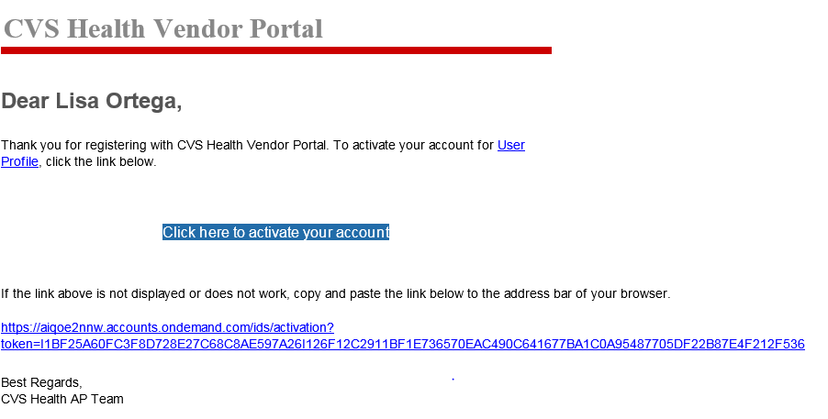

This link will prompt you to your account. You will then be asked to complete your account information (see below) Click Continue once completed.



**Profile Setup**

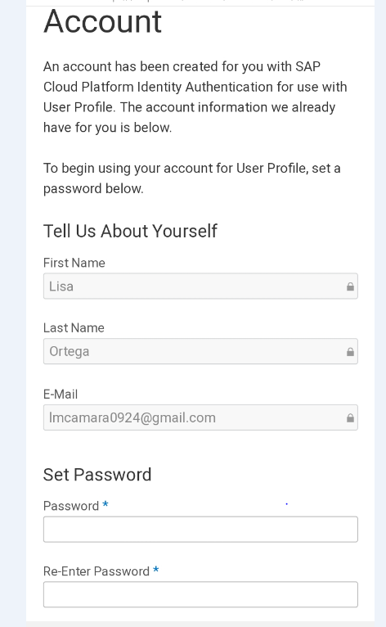

You will be directed to your Profile Management (Containing Personal Information, Password, Company Information, Two-Factor Authentication, Social Sign-On and my Data). You will then need to active a Two-Factor Authentication.

**The Two-Factor Authentication** is a CVS requirement and will need to be completed to access your account. (***NOTE- Do not delete this app as you will need to use the SAP Authentication to access a passcode everytime you login to your account.)***

You are able to use your mobile phone or use your desktop to active your Two-Factor Authentication (see instructions below)

**YOU CAN ONLY USE ONE DEVICE (EITHER YOUR PHONE OR DESKTOP) TO DOWNLOAD THE SAP TWO-FACTOR AUTHENTICTION**

If the SAP Two-Factor Authentication is downloaded on multiple devices, then the user will not be able to log into the CVS AP vendor portal.

**SAP Authenticator: Mobile Phone Version**

Note: If the SAP Two-Factor Authenticator is already on your desktop, do not download the mobile version.

This App is available on Google playstore for Android

[**https://play.google.com/store/apps/details?id=com.sap.csi.authenticator&hl=en_US**](https://play.google.com/store/apps/details?id=com.sap.csi.authenticator&hl=en_US)

and Appstore for IOS.

[**https://itunes.apple.com/us/app/sap-authenticator/id868171828**](https://itunes.apple.com/us/app/sap-authenticator/id868171828)

Once you have downloaded the app, you will scan the QR Code from your Profile page on to your mobile device. Your mobile device will provide you a 6 digit number. You will enter this key code into the Passcode field as seen below. Then click Activate. This will active your account.

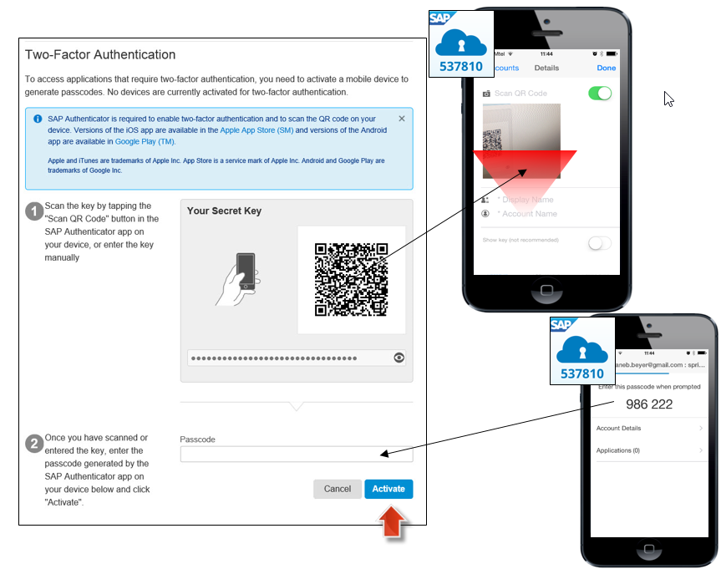

**NOTE: Please make sure that your phone’s date/time settings are set to “Automatically” to account for any time differences.**

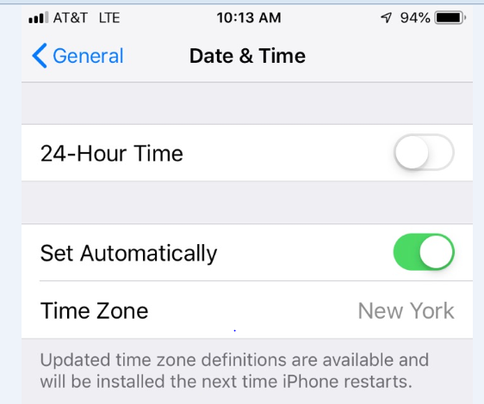

**SAP Authenticator: Desktop Version**

Note: Before downloading the SAP application on your computer, please ensure the following:

* The SAP Two-Factor is not already downloaded on your mobile phone
* You will need to use the Chrome Browser
* Must have Windows 8 or later
* You must ensure there are no internal firewalls set up. You will need to contact your internal IT area to confirm. If there are firewalls, then your IT area must download this for you.

The mobile version of SAP Authenticator is the preferred and suggested way of logging into the Vendor Portal through MFA. If using the mobile version is not possible, SAP Authenticator can be downloaded through the Microsoft store by following these steps.

1. The following link navigates to the SAP Authenticator App in the Microsoft Store <https://www.microsoft.com/en-us/p/sap-authenticator/9nblggh4s7q7?activetab=pivot:overviewtab>

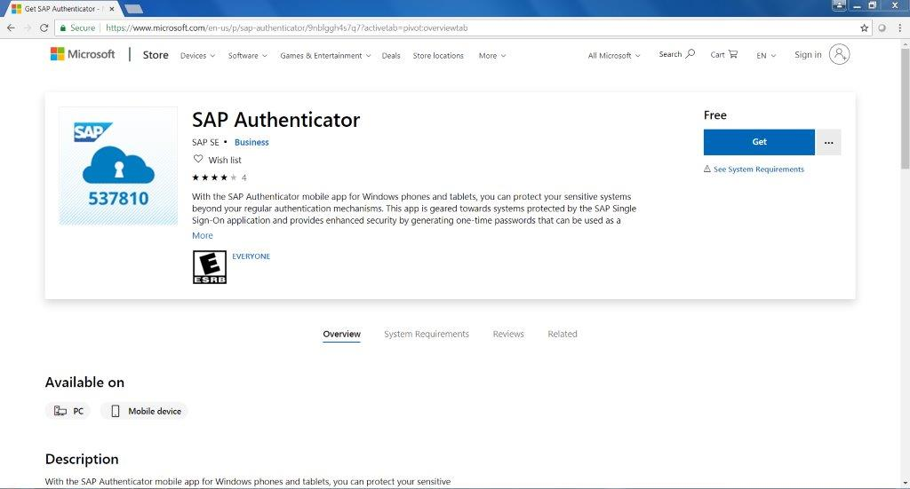

1. After clicking on “Get”, you will be prompted to sign into your Microsoft account or create one.

1. Click next

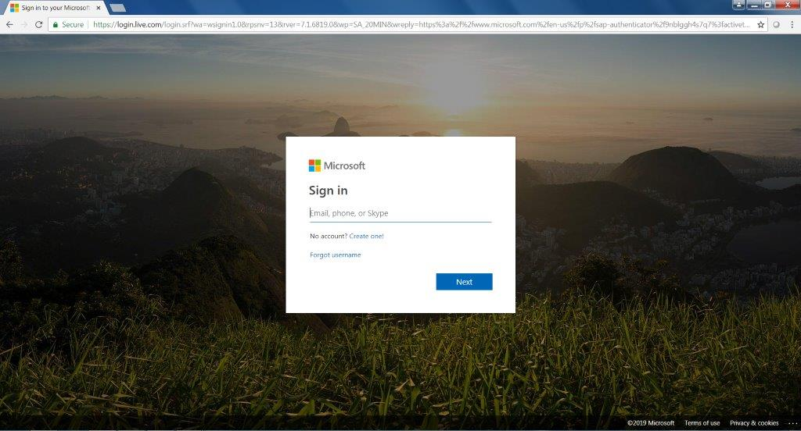

1. You will then be able to install the application. (click install on my devices)

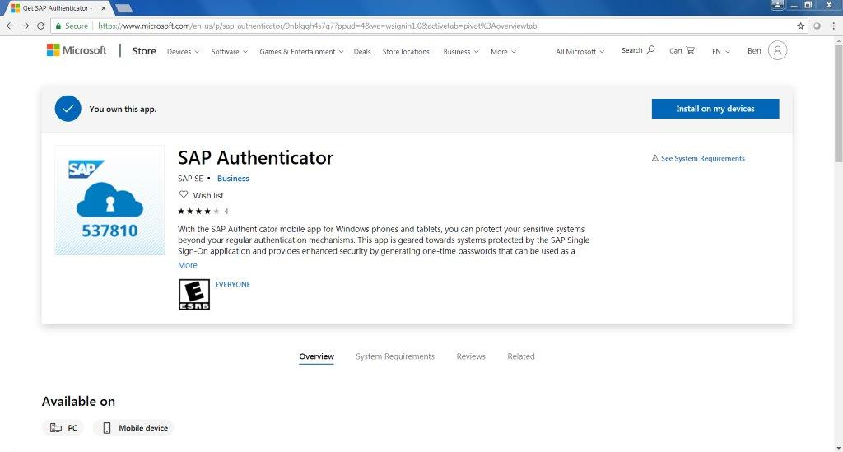

1. When the SAP Authenticator desktop application opens, you will be prompted to enter the security key which can be obtained by clicking on the “show” icon and copying the key to your clipboard.

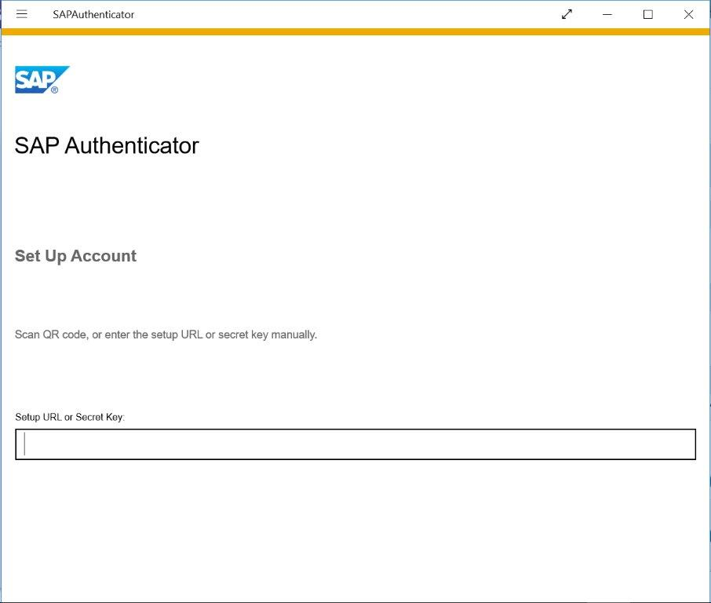

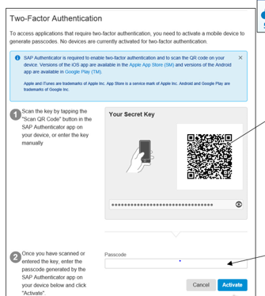

On

Click on the “Show” icon in the Two-Factor page. This will display the Secret Code. Copy & Paste this code into the URL SAP Authenticator field and click continue. A 6 digit code will be displayed. Use this code to key into the Passcode under the Secret Key field and click Active.

It is important to copy all **25 digits** of the secret key into the Secret Key field

**Note:** Downloading the application requires Windows 8 or later. If your system security prevents you from downloading SAP Authenticator to your desktop, please use the mobile version or contact your company IT department to install the app.

Once completed, log out of your profile. In a new browser login using apvendorportal.cvshealth.com and access your account using your email address and passcode (this is the generated code from your SAP Authentication). NOTE – a new code will generate every 30 seconds.

**FOR USERS WITH AN EXISTING PROFILE ACCOUNT AND HAVE NOT SET UP TWO-FACTOR AUTHENTICATION**

***This step is only needed if the user has not completed the activation of the SAP Two-Factor Authentication either on their mobile phone or desktop. If you have already completed this, proceed to the Login Page.***

***NOTE- DO NOT DELETE THE SAP AUTHENTICATOR FROM YOUR DEVICE.  YOU WILL NEED IT EVERY TIME YOU LOG INTO THE PORTAL.***

1. Sign into the vendor portal at <https://apvendorportal.cvshealth.com>

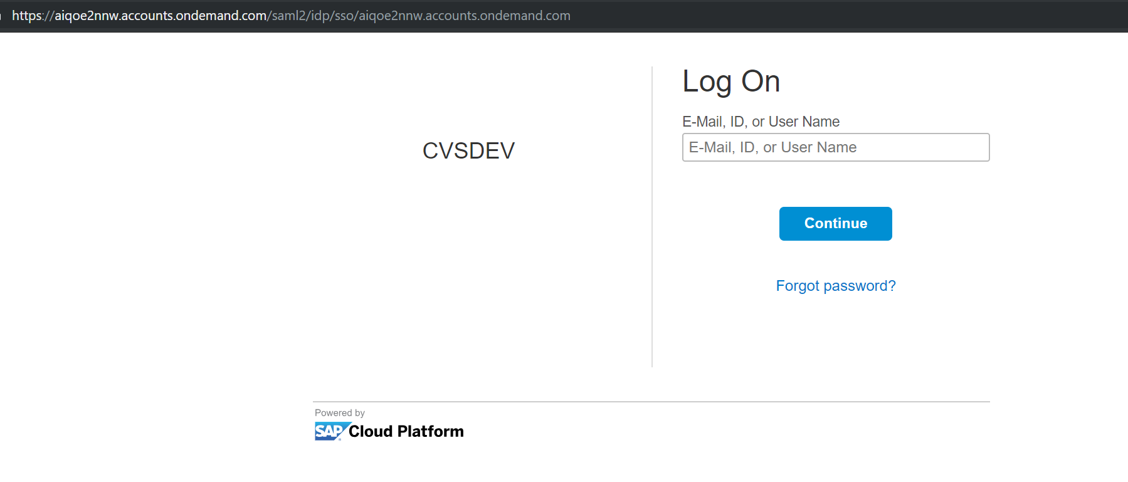

1. Enter your user name and password and click on Continue

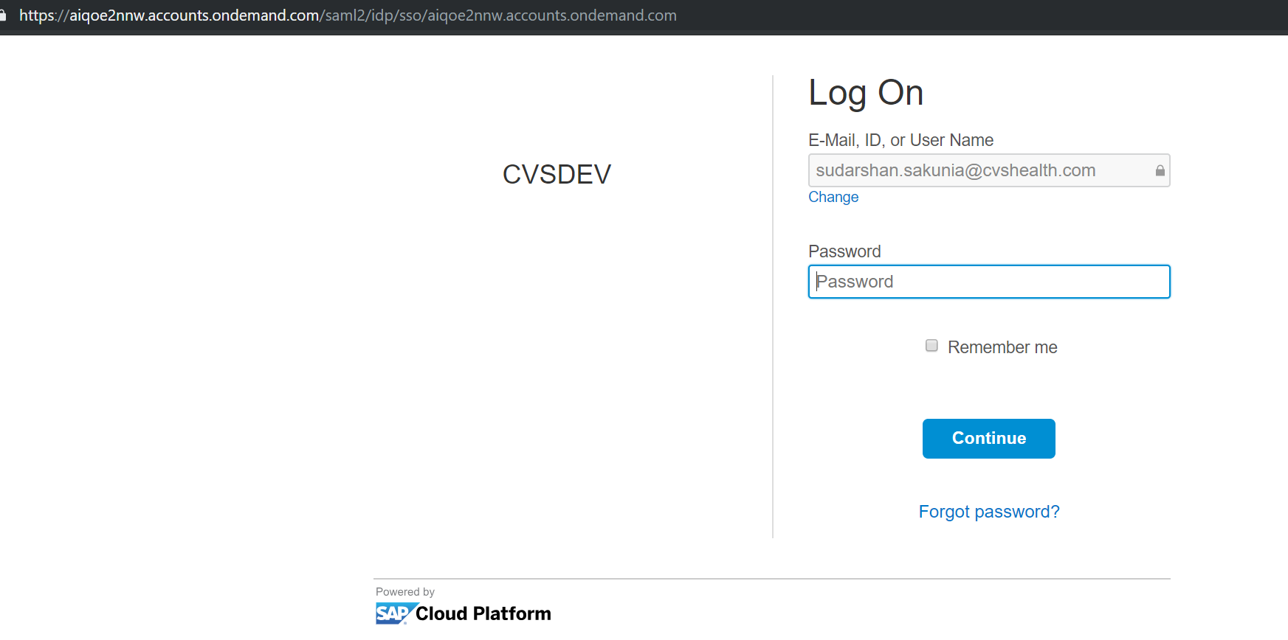

If the SAP Two-Factor is not already set up on your profile, you will be directed to this page. Click on the Profile Page to start the Two-Factor Authenication process.

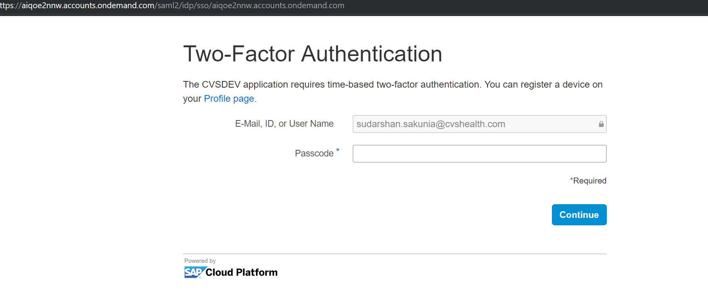

1. Click on Activate.

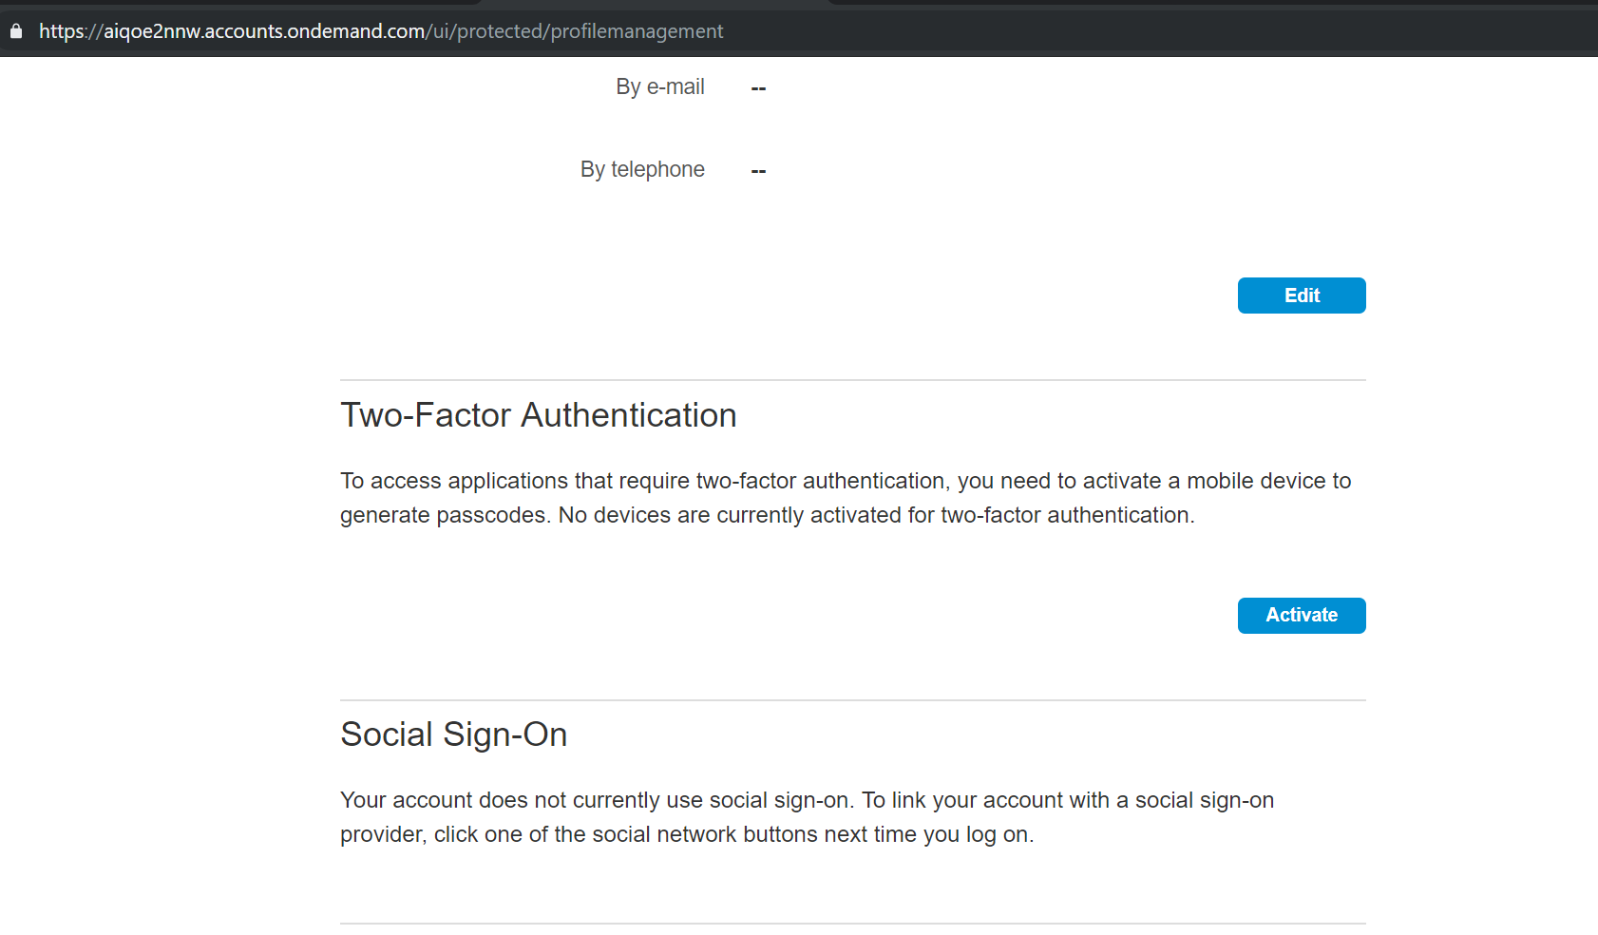

Proceed to the instructions to either download the SAP Two-Factor Authentication either from your phone (Page 4) or desktop (Page 5).

Once the Two-Factor has been completed, you will see that the device has been configured to your account.

Example of a succesful actived Two-Factor Authentication

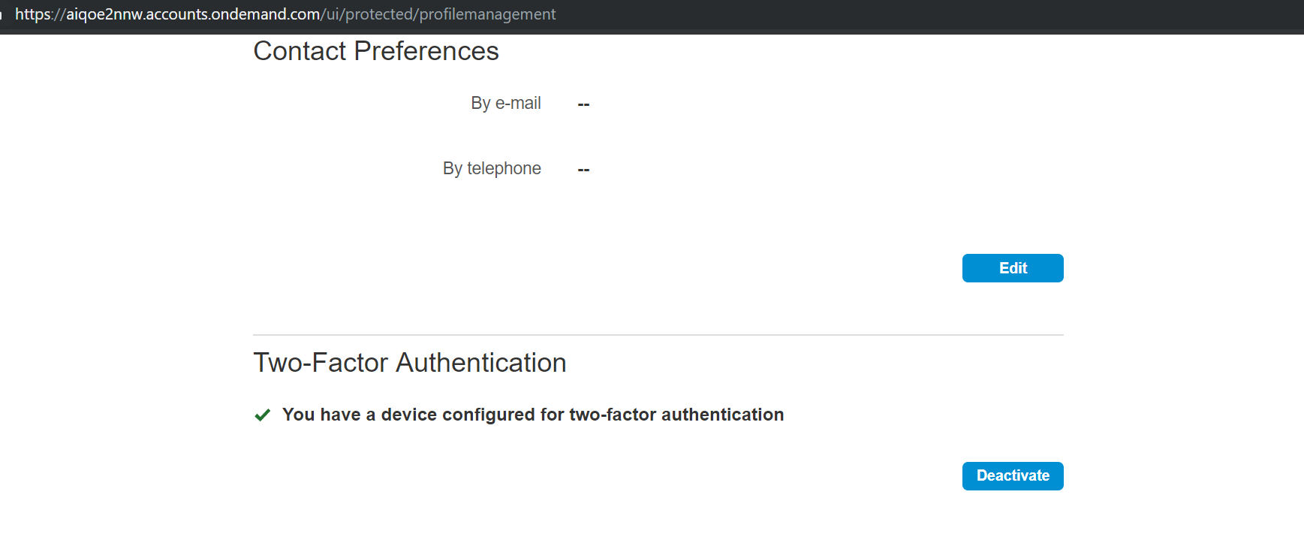

Once you receive this successful message, log out of the user profile page.

**User Login And Entering the Two-Factor Authenticator Passcode**

1. Enter your email address and click log On

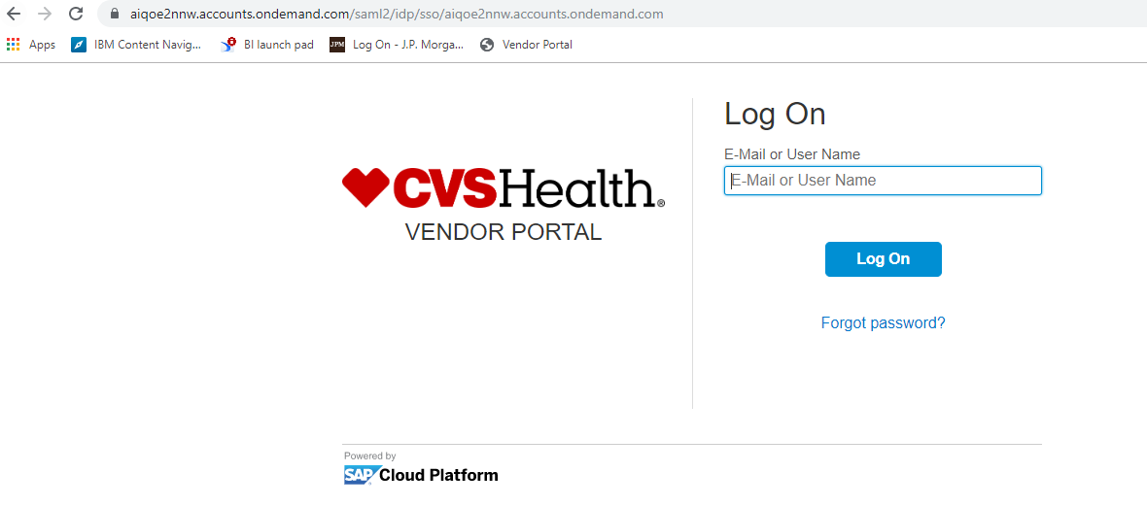

1. Enter your password and click Log On

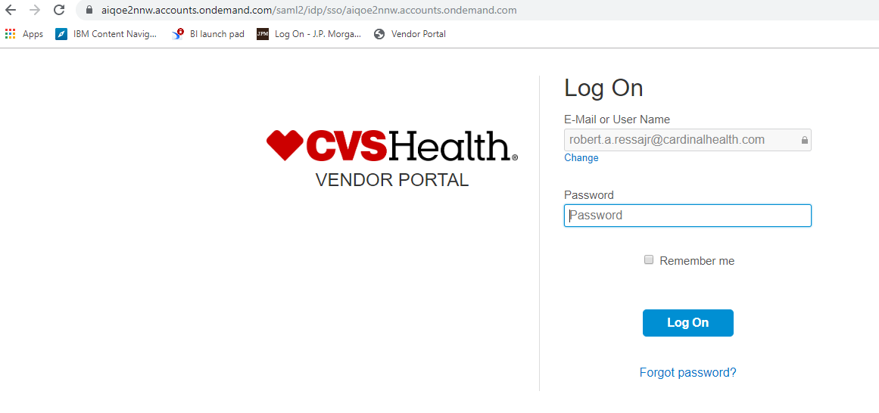

1. In the initial authentication screen, key in the generated passcode from the SAP Authenticator App to the Passcode field to login to the Vendor portal application.

**Example of using your mobile phone.**

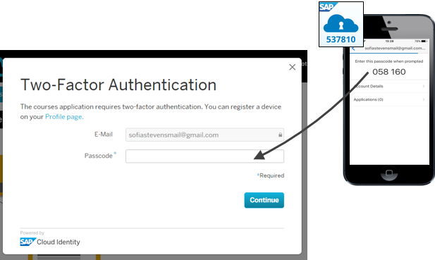

**Example of using your desktop.**

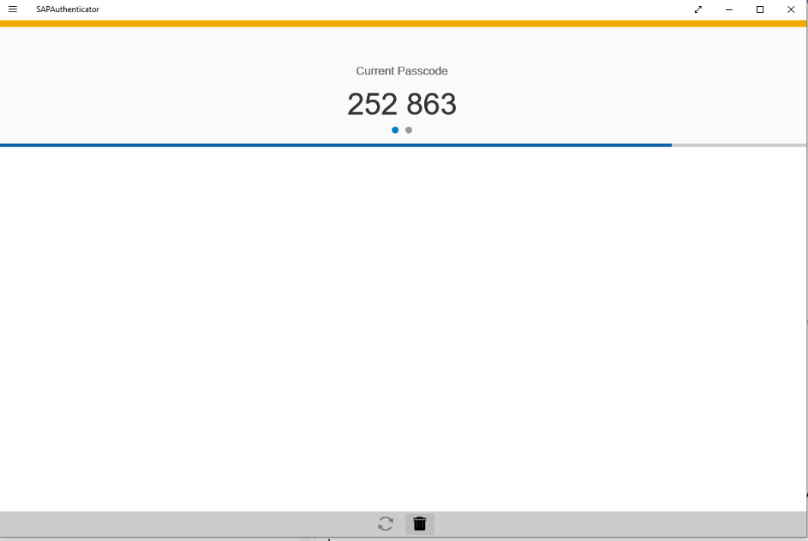

1. Enter the generated 6 digit passcode provide (either using your phone or desktop version) into the passcoode field and click Contuine. This generate code will change every 30 seconds.

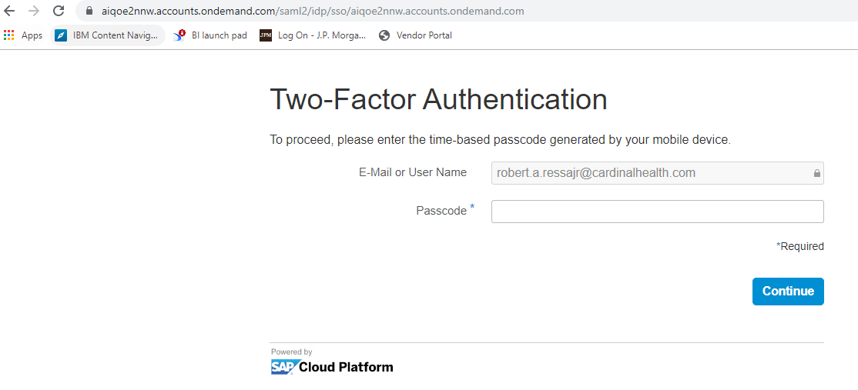

Once the user has sucessfully logged in to the portal, the user will be directed to the CVS Vendor Portal Dashboard (as seen below)

There will be three tiles that can be accessed by clicking on the tile shown below.

* CVS Vendor Portal – this title view provides a Weekly Net Payments of 5 weeks; Vendor Information, Invoice Title and Payment title. You can access invoice and payment information from this tile. Or you can use the below Invoice and Payment tile from your homepage to access this information.
* Invoice- view of open payables
* Payment- view payment history

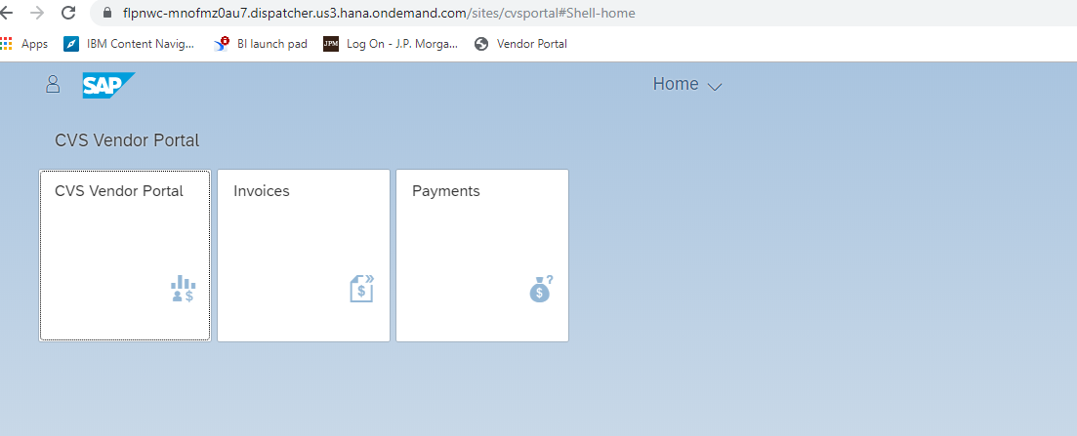

Veiw of the CVS Vendor Portal Page

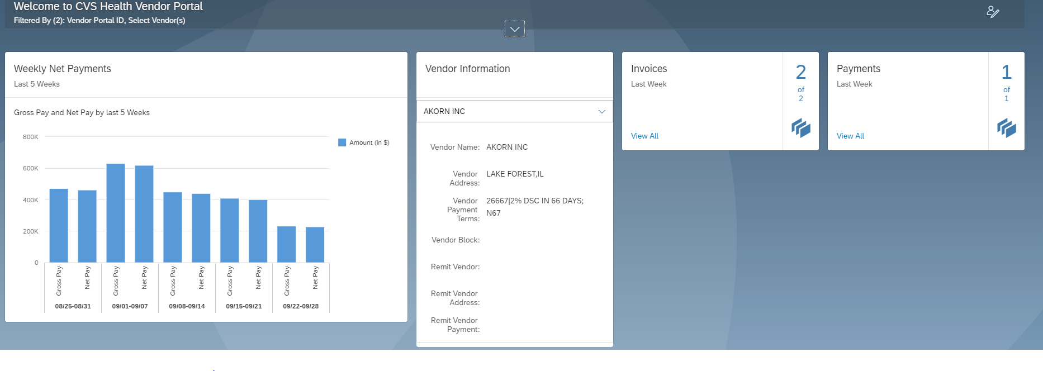

### View invoices (open payables)

**Follow these steps to run reports for invoices:**

|  |  |
| --- | --- |
| Step | Action |
| 1 | Log in to **CVS** **Vendor Portal**. |
| 2 | Click the **Invoices** tile. (Either using the CVS home page or CVS Vendor Portal Tile) |





|  |  |
| --- | --- |
| Step | Action |
| 3 | Invoices are displayed based on the search criteria. (as seen below) |
| 4 | Update the filter criteria and click the **Go** button. |

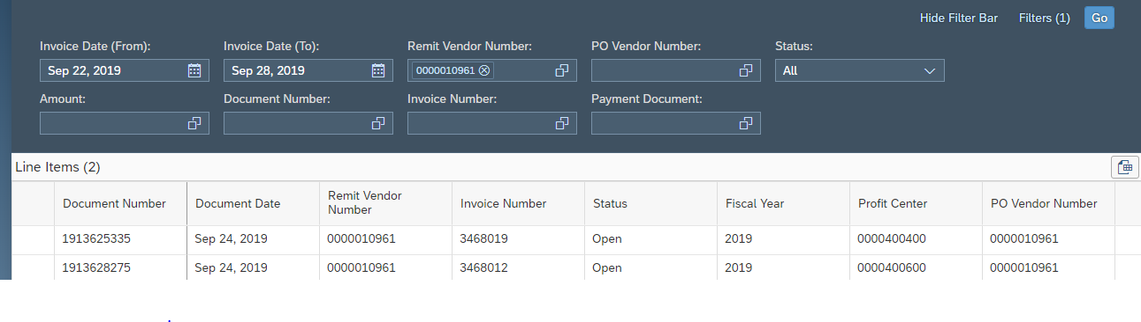

**Note**- For open payables on your account, click on the **Status** field and choose OPEN. This function will clear out the Invoice dates and will display all open invoices that have **NOT** been paid or soon to be paid.

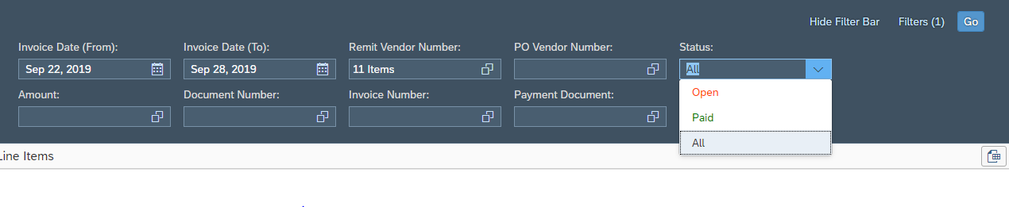

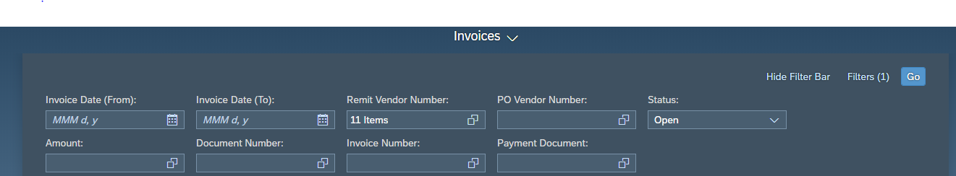

|  |  |
| --- | --- |
| Step | Action |
| 5 | Click the **Export to Spreadsheet** to download the results if needed. |

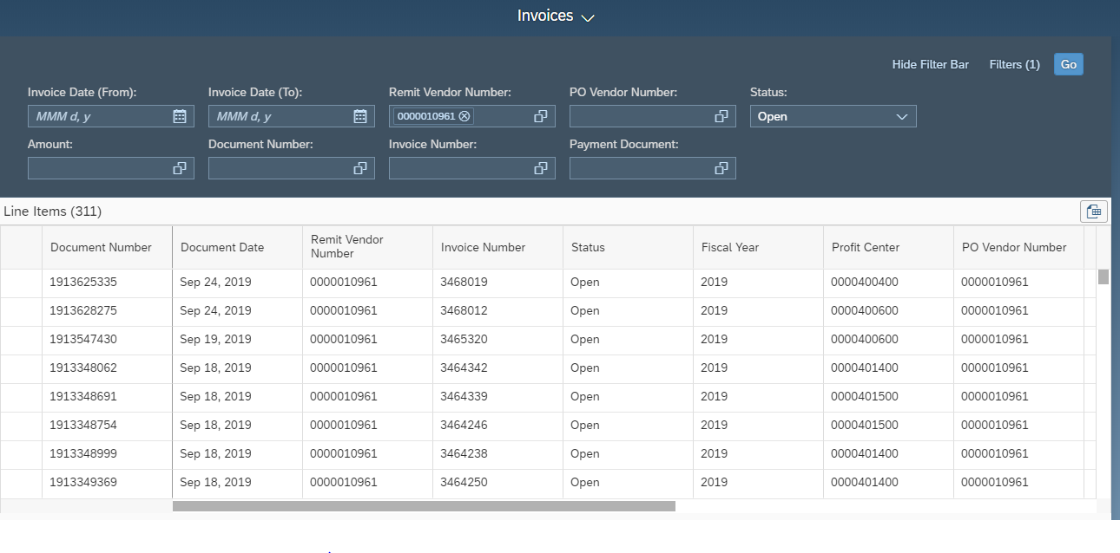

Click on the scroll bar to see additional invoice information



### View Payments

**Follow these steps to run vendor reports for payments:**

|  |  |
| --- | --- |
| Step | Action |
| 1 | Log in to **CVS** **Vendor Portal**. |
| 2 | Select the **Payments** tile. (Either using the CVS home page or CVS Vendor Portal Tile) |





|  |  |
| --- | --- |
| Step | Action |
| 3 | Invoices are displayed based on the search criteria. |
| 4 | Update the filter criteria and click the **Go** button. |

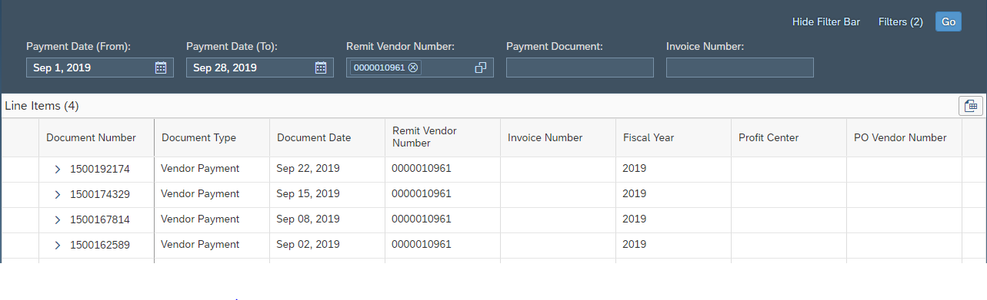

To view invoices associated with payment, click on the **>** symbol. This will provide you the list of invoices or deduction information.

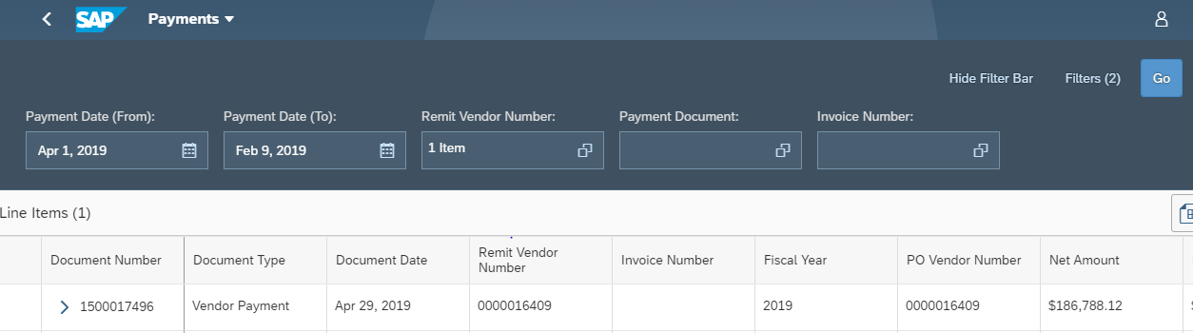

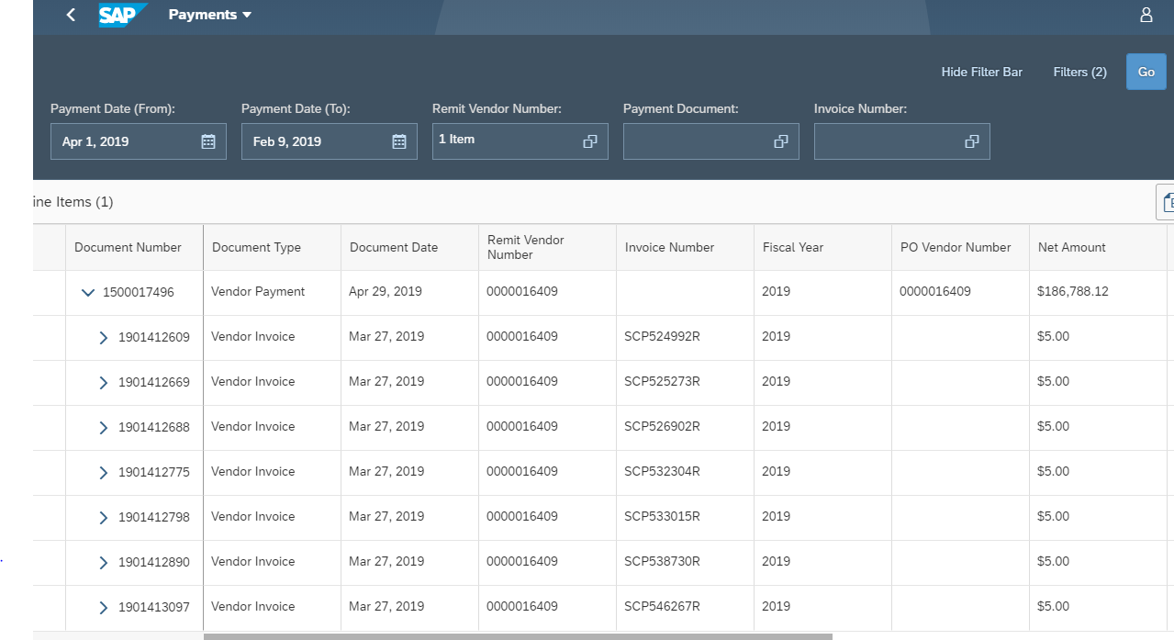

Vendor invoice

|  |  |
| --- | --- |
| Step | Action |
| 5 | Click the **Export to Spreadsheet** to download the results if needed. |

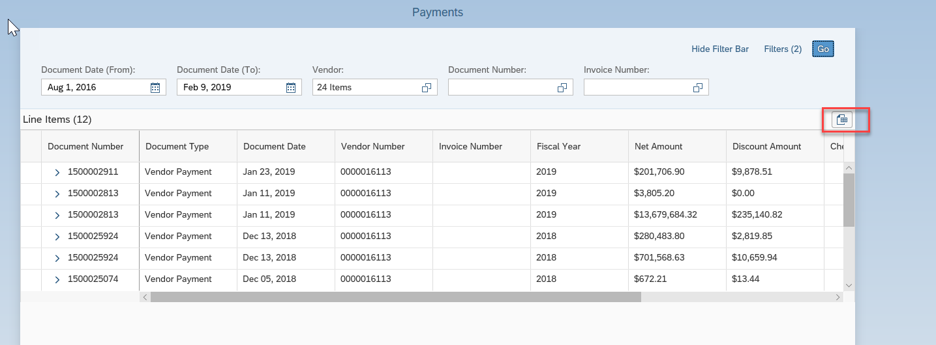

Click on the scroll bar to see additional payment information

### Password Change

**Follow these steps to change account password:**

**NOTE: Make sure that your Google account is not auto-populating your pervious password. You will have to update this every time you change/update your password.**

|  |  |
| --- | --- |
| Step | Action |
| 1 | Navigate to log in screen of **CVS** **Vendor Portal**. |
| 2 | Click the **Forgot Password** button. |

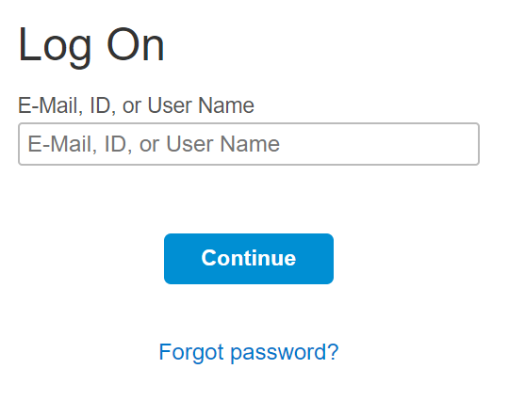

|  |  |
| --- | --- |
| Step | Action |
| 3 | Enter Email/User Name/User ID |
| 4 | Click the **Send** button. |

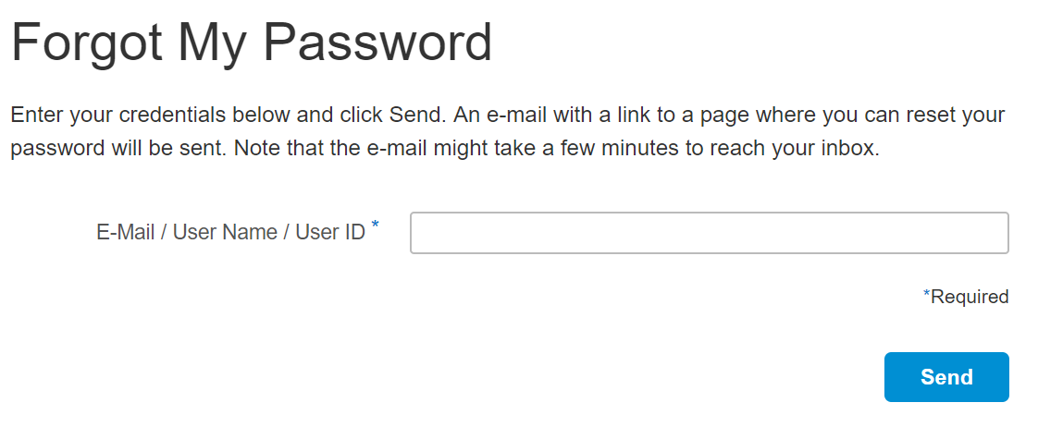

|  |  |
| --- | --- |
| Step | Action |
| 5 | Click the link contained in the e-mail and you will be forwarded to a page where you can reset your password |

**Error Messsages**

|  |  |  |
| --- | --- | --- |
| **Error Message** | **Description** | **Solution** |
| Wrong passcode; enter  passcode again | You have entered a wrong passcode when setting up an account on additional device or when disabling an account. | Reenter the passcode generated by your  mobile device. |
| You have not entered the passcode within the specified time interval | Enter the passcode within the specified time interval. It is 30 seconds for users with the SAP Authenticator installed. |
| Your clock is not synchronized with the  clock on the server. | Configure your mobile device to automatically update the date and time under Settings – General - Date & Time -  Set Automatically |

SAP references :

<https://help.hana.ondemand.com/cloud_identity/0d41cd49f6504f3eaf29b58d616b040f.html>

<https://blogs.sap.com/2015/07/16/enable-two-factor-authentication-with-sap-cloud-identity-service/>

For Additional common account activation issues and solutions, please refer the Vendor Portal FAQ located on the user’s home page.